1.
Draw a labeled diagram of a desktop PC, clearly marking the motherboard, CPU, RAM, GPU, and both HDD and SSD storage components.

• Motherboard: The main flat circuit board that spans the back of the computer case, providing electrical pathways and slots to connect every other hardware piece.

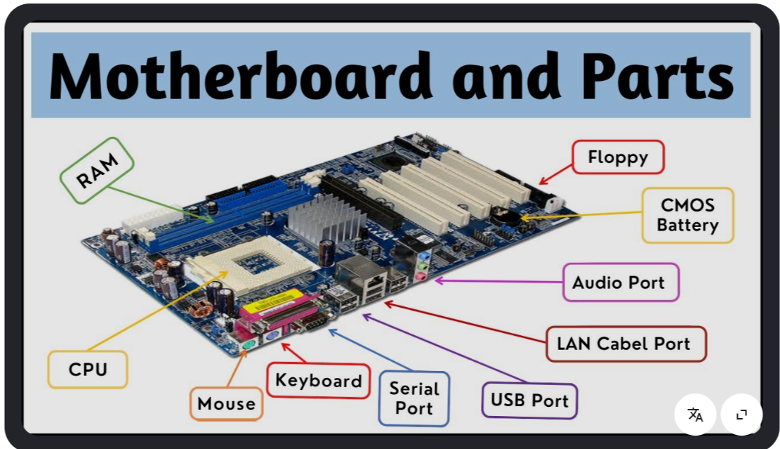

• CPU (Central Processing Unit): A small square chip plugged into a retention socket near the upper-middle section of the motherboard, typically covered by a metallic cooling heatsink.

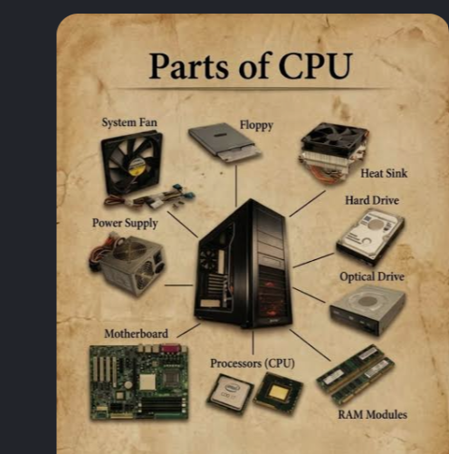

• RAM (Random Access Memory): Long, thin rectangular memory modules slotted vertically or horizontally right next to the CPU socket for fast, temporary data access.

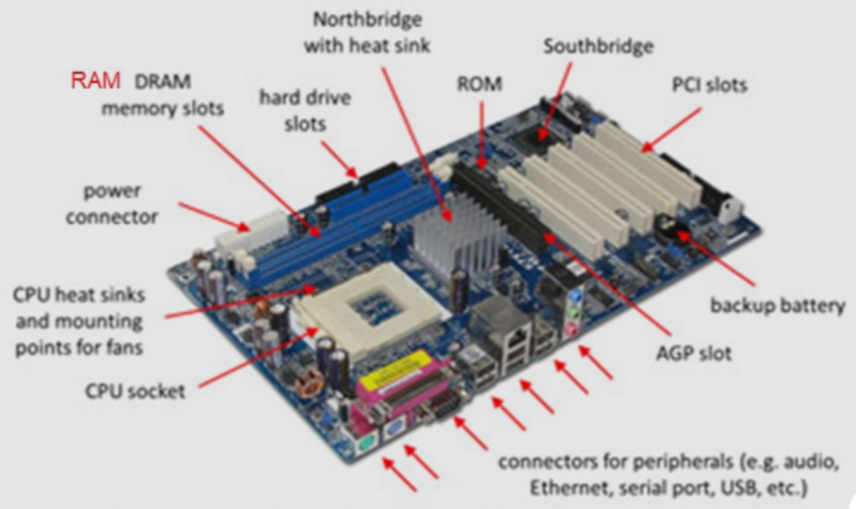
• GPU (Graphics Processing Unit / Graphics Card): A large rectangular expansion card plugged into a horizontal PCIe slot in the lower half of the motherboard to manage visual and gaming output.

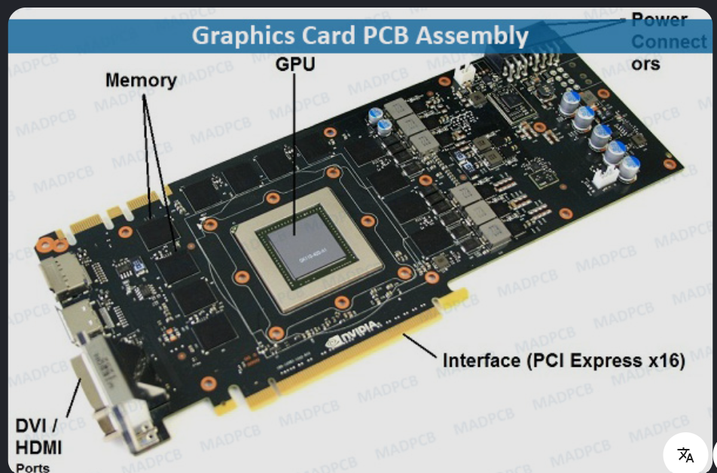

• HDD (Hard Disk Drive): A mechanical long-term storage unit with internal spinning magnetic disks, usually mounted inside a dedicated drive bay at the bottom or front corner of the computer case.

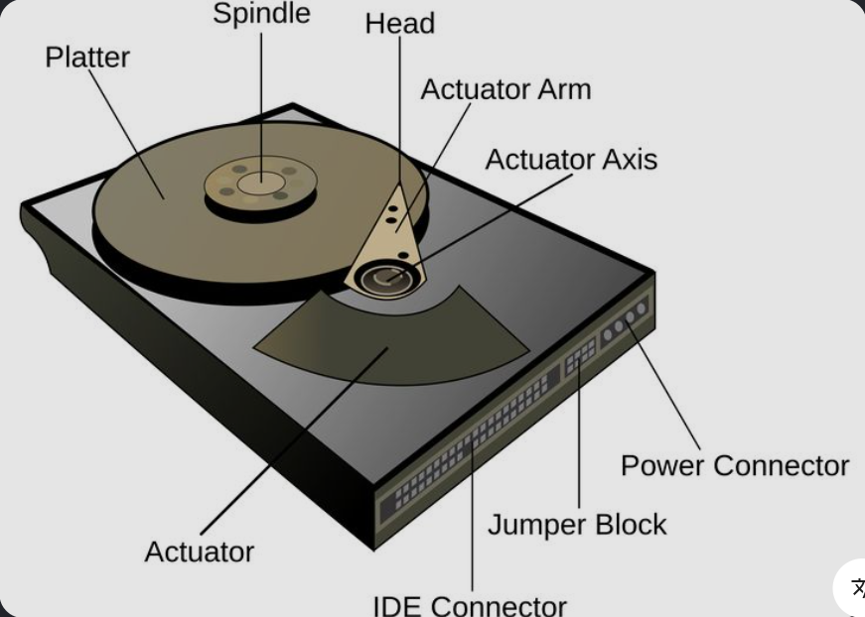

• SSD (Solid State Drive): A compact flash-based long-term storage component that either plugs directly onto the motherboard via an M.2 slot or mounts as a flat rectangular drive connected via cables.

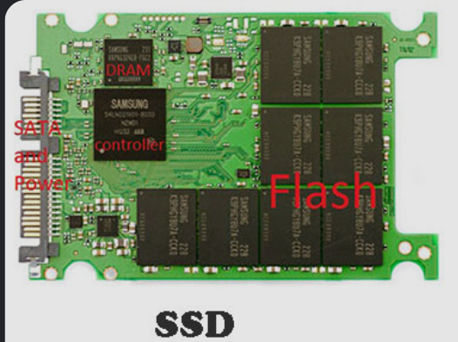

2.
Create a comparison table showing the main differences between HDD and SSD storage in terms of speed, durability, and typical use cases.<br><br><em><strong>Hint:</strong> Think about which one is faster, which is more shock-resistant, and where you would usually find each type (laptop, gaming PC, etc.).</em>

Feature | HDD | SSD
Speed | Slower | Much faster
Durability | Less shock-resistant because it has moving parts | More shock-resistant because it has no moving parts
Typical use | Large, inexpensive storage; desktop PCs and backups | Laptops, gaming PCs, operating-system and game storage
Noise | Can make some noise | Silent
Cost per GB | Usually cheaper | Usually more expensive

3.
Write a short explanation (2-3 sentences each) describing the role of the CPU, RAM, and GPU in running a game like PUBG or Free Fire on a PC.

CPU
The CPU (Central Processing Unit) handles the game's main calculations and instructions. It manages tasks such as game logic, physics, AI, and communication between different hardware components.

RAM
RAM (Random Access Memory) temporarily stores game data that the CPU needs to access quickly. More RAM helps the PC run the game smoothly while also allowing other programs to remain open.

GPU
The GPU (Graphics Processing Unit) creates the images, textures, lighting, and visual effects displayed on the screen. A stronger GPU generally allows games such as PUBG or Free Fire to run at higher graphics settings and frame rates.

4.
Imagine you want to upgrade your PC to run the latest version of FIFA smoothly. List which hardware components you would consider upgrading and explain why for each.

- GPU: Upgrade this first if the current graphics card struggles with the game's graphics requirements. A newer GPU can provide higher frame rates and better visual quality.
- CPU: Consider a faster processor if the current CPU is old or causing low frame rates, especially during scenes with lots of game activity.
- RAM: Upgrade the RAM if the PC has too little memory. Having sufficient RAM helps prevent stuttering and improves multitasking.
- SSD: Installing FIFA on an SSD can significantly reduce loading times and make the overall system feel more responsive.
- Power supply (PSU): If you install a more powerful GPU, check that the PSU can safely provide enough power.
- Cooling: A better CPU cooler or improved case airflow may be needed if upgraded components generate more heat.

